**1.** Draw the UML Diagram for Library Management System, Library Management System gives us the complete information about the library and the daily transactions done in a Library. We need to maintain the record of books and retrieve the details of books available in the library which mainly focuses on basic operations in a library like adding new member, new books, and up new information, searching books and members and facility to borrow and return books. It features a familiar and well thought-out, an attractive user interface, combined with strong searching, insertion, and reporting capabilities. The report generation facility of library system helps to get a good idea of which are borrowed by the members, makes users possible to generate hard copy. Draw the Use case diagram, Class diagram, Activity diagram and Sequence diagram for Library Management System

**Solution:**

**Class Diagram:**

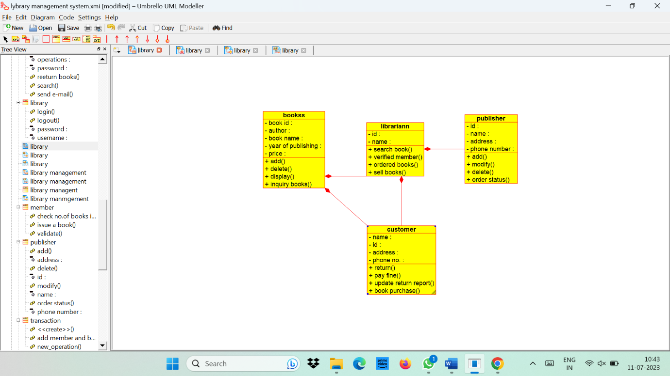

**Usecase Diagram:**

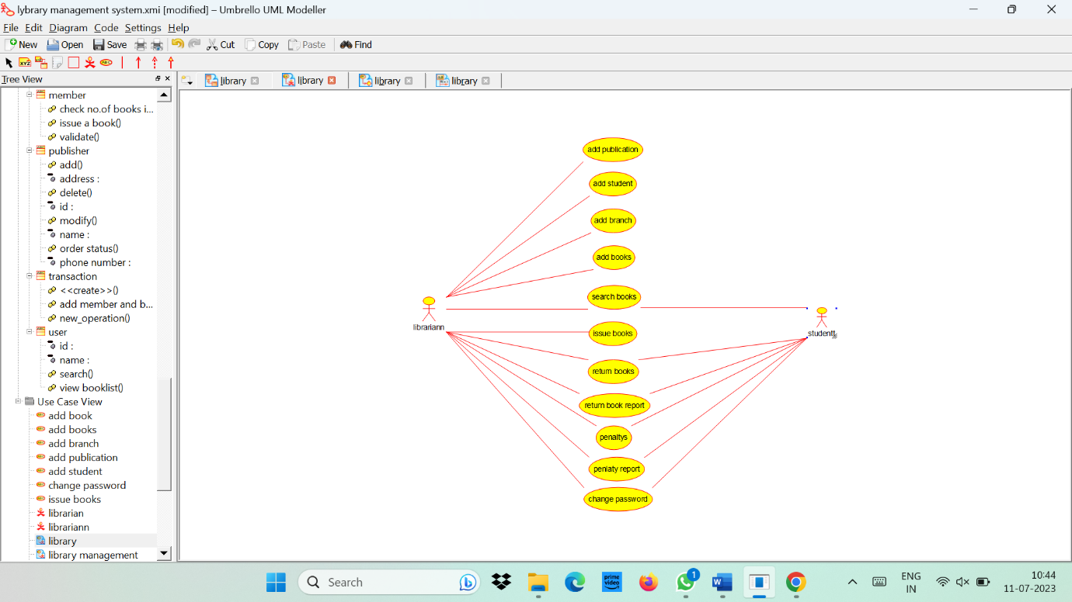

**Activity Diagram:**

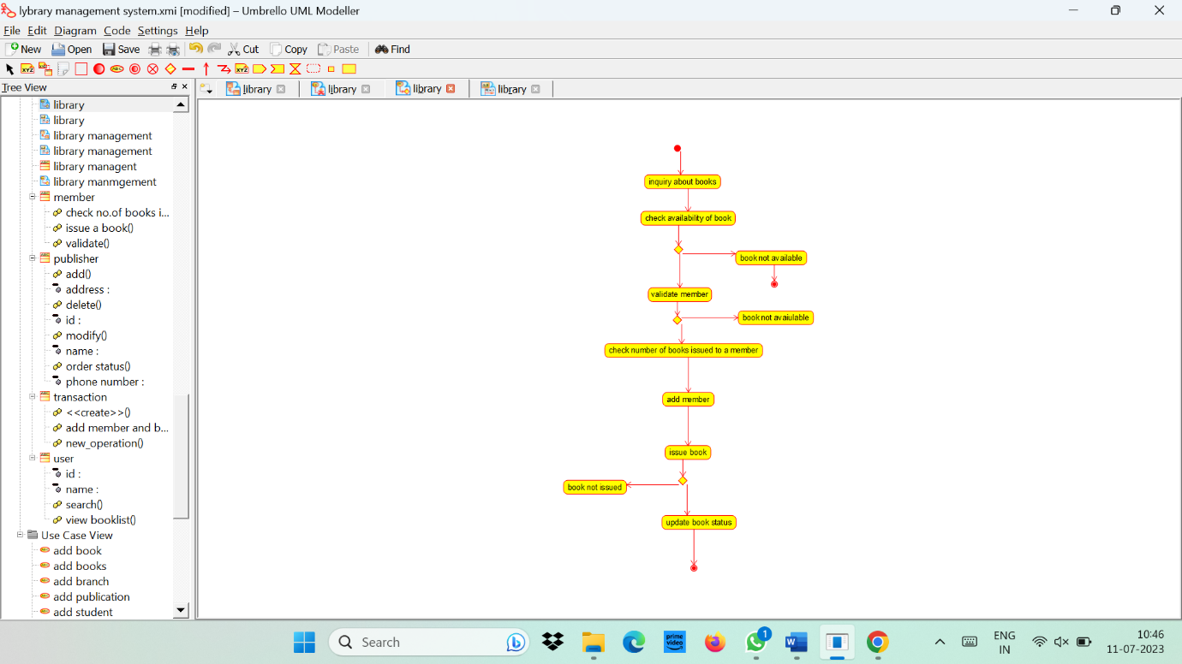

**Sequence Diagram:**

